2024 SDHCA Volunteer Awards Program
Nomination Packet
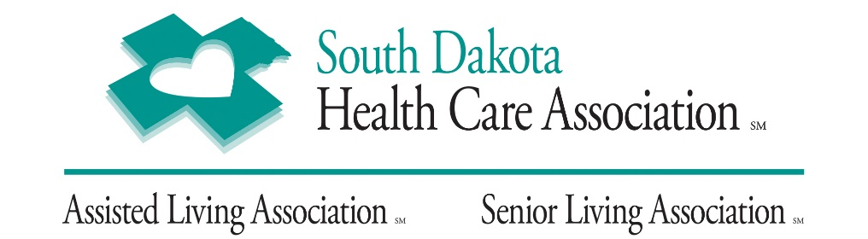

Application must be in SDHCA office no later than July 25, 2024.
Nominees must have volunteered in a member facility for at least one continuous year prior to being nominated for the award.

SDHCA will recognize the Volunteer of the Year winners at the
SDHCA Fall Convention.
Volunteers significantly improves the daily life of the residents or members
of the communities they serve.
Following are the requirements for the
Volunteer of the Year Award for one of the following:
Adult, Young Adult, or Group

Volunteer of the Year Categories

SDHCA will honor one volunteer from each category:
- Adult—an individual, 20 years of age or older, who has volunteered in a member facility for at least one continuous year prior to being nominated for the award.
- Young Adult—an individual, 13 to 19 years of age, who has volunteered in a member facility for at least one continuous year prior to being nominated for the award.
- Group—a distinct organization that has provided group volunteer services or participated in a series of
activities with a member facility’s residents for at least one continuous year prior to being nominated for the award. Examples of this category include, but are not limited to: Boy and Girl Scouts, Rotary Clubs, garden clubs, employee clubs, church groups, etc. People informally volunteering together do not constitute a group and do not qualify.

Eligibility Criteria

All entries must meet the following criteria:
  - Submit nominations by mail by July 25th to the South Dakota Health Care Association,
804 N Western Avenue, Sioux Falls, SD 57104.
  - Multiple volunteer awards may be awarded in the same member facility in any given year.
  - Nominees must be current volunteers and have served one continuous year at the facility.
  - Facilities must be Members in good standing with SDHCA at the time of judging.

Selection Criteria

A panel of judges will rank the nominees in each category based on the following criteria:
- Ability to help residents achieve their potential;
- Overall impact on residents either individually or collectively;
- Personal involvement with residents;
- Leadership in initiating programs for residents;
- Encouraging others to volunteer; and
- Goes above and beyond the call of duty.

Recognition of Honorees

To show Volunteer of the Year honorees how much we, as a profession, appreciate their service to the long term and post-acute care community, SDHCA hold the awards presentation during its Annual Convention each fall. As part of the recognition, SDHCA will invite the adult honoree and one guest; the young adult honoree and a parent or guardian; and one group honoree and a guest, to participate in convention award activities.
Submit a Nomination

Submit forms by mail to SDHCA, 804 N Western Avenue, Sioux Falls, SD 57104. Questions can be submitted to luannseverson@sdhca.org.

2024 Volunteer of the Year Nomination Form for any of the following:
Adult / Young Adult / Group
(Submit application to the SDHCA office no later than July 25, 2024.) Mail forms to:
South Dakota Health Care Association
804 N Western Avenue
Sioux Falls, SD 57104
Questions can be emailed to: luannseverson@sdhca.org

Section I

Which Volunteer of the Year (VOY) category are you applying for? (Check only one)

  - Adult VOY
  - Young Adult VOY
(Must be 13 to 19 years old)
    - Age of Volunteer: _______________
  - Group VOY
    - A few people informally volunteering together do not constitute a group

Section I: Nominee’s Information

Nominee’s Name: _______________________________________________________________
Nominee’s Address: ______________________________________________________________
Nominee’s Telephone Number: __________________________
Nominee’s Email Address: ______________________________

Section II: Nominator’s Information

Center’s Name: ___________________________________________________________________
Center’s Address: __________________________________________________________________
Total Number of Beds at the center: ___________
Nominator’s Name/Title: ___________________________________________________________
Nominator’s Telephone Number: __________________
Nominator’s Email Address: _________________________________________________________

Please provide the following information about your Nominee and his/her care center:
- Length of volunteer service at your center: ____________ years
- Frequency of service:
    - Nominee serves: _______ hours per week, or ___________ hours per month

Section III - Essay
If applicant uses separate sheets, please repeat the question and
use same alpha format.

In 500 words or less, explain the following:
o How the nominee personally interacts with residents;
o How the nominee's leadership in initiating programs for residents;
o How the nominee’s efforts to encourage others to volunteer at the center; and
o How the volunteer goes above and beyond the call of duty to help residents reach their full potential, how the nominee improved residents’ quality of life, and what makes this nominee noteworthy.
Write Essay here:

Section IV – Letters of Recommendation
- A letter from the center’s owner, executive director or administrator.
- A letter from a center leader in a management role (i.e. Director of Nursing/DNS).
- A letter from a resident, a resident’s family member, or a resident’s friend who frequently visits (note: this letter may not be from a staff member).

Additional Reference Letters (Optional)
1. Optional reference letters may not exceed one page;
2. Letters must be personally signed; and
3. Letters must address the following characteristics of the nominee:
- Work ethic;
- Commitment to serving; and
- Ability to connect with residents and patients.

(Submit application to the SDHCA office no later than July 25, 2024)
Mail forms to:
South Dakota Health Care Association
804 N Western Avenue
Sioux Falls, SD 57104
Questions can be emailed to: luannseverson@sdhca.org

